P032 - Garden Fleet 01 Schedule
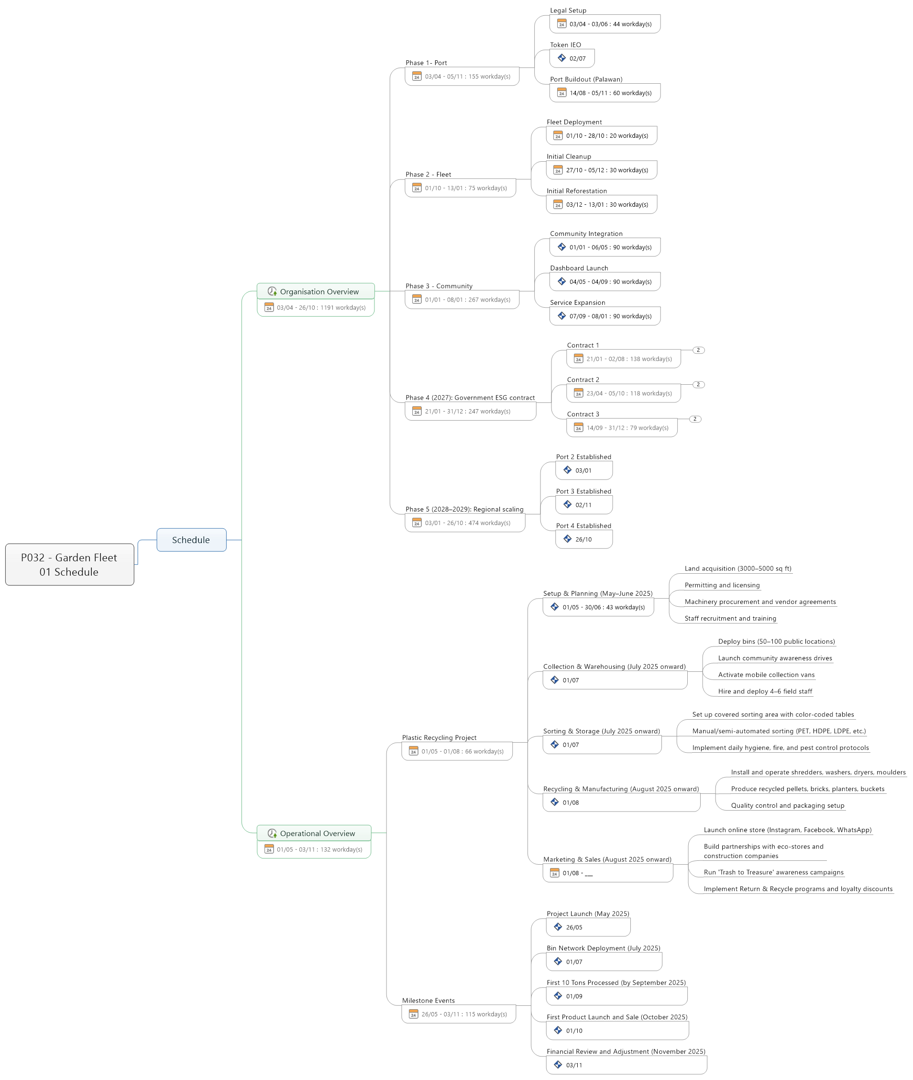
- Schedule
  - Organisation Overview
    - Phase 1- Port
      - Legal Setup
      - Token IEO
      - Port Buildout (Palawan)
    - Phase 2 - Fleet
      - Fleet Deployment
      - Initial Cleanup
      - Initial Reforestation
    - Phase 3 - Community
      - Community Integration
      - Dashboard Launch
      - Service Expansion
    - Phase 4 (2027): Government ESG contract
      - Contract 1
        - Onboarding
        - Auditing
      - Contract 2
        - Onboarding
        - Auditing
      - Contract 3
        - Onboarding
        - Auditing
    - Phase 5 (2028–2029): Regional scaling
      - Port 2 Established
      - Port 3 Established
      - Port 4 Established
  - Operational Overview
    - Plastic Recycling Project
      - Setup & Planning (May–June 2025)
        - Land acquisition (3000–5000 sq ft)
        - Permitting and licensing
        - Machinery procurement and vendor agreements
        - Staff recruitment and training
      - Collection & Warehousing (July 2025 onward)
        - Deploy bins (50–100 public locations)
        - Launch community awareness drives
        - Activate mobile collection vans
        - Hire and deploy 4–6 field staff
      - Sorting & Storage (July 2025 onward)
        - Set up covered sorting area with color-coded tables
        - Manual/semi-automated sorting (PET, HDPE, LDPE, etc.)
        - Implement daily hygiene, fire, and pest control protocols
      - Recycling & Manufacturing (August 2025 onward)
        - Install and operate shredders, washers, dryers, moulders
        - Produce recycled pellets, bricks, planters, buckets
        - Quality control and packaging setup
      - Marketing & Sales (August 2025 onward)
        - Launch online store (Instagram, Facebook, WhatsApp)
        - Build partnerships with eco-stores and construction companies
        - Run 'Trash to Treasure' awareness campaigns
        - Implement Return & Recycle programs and loyalty discounts
    - Milestone Events
      - Project Launch (May 2025)
      - Bin Network Deployment (July 2025)
      - First 10 Tons Processed (by September 2025)
      - First Product Launch and Sale (October 2025)
      - Financial Review and Adjustment (November 2025)

